ОСНОВЫ ТЕОРИИ ГРАФОВ
Лекция № 2

Задание 1
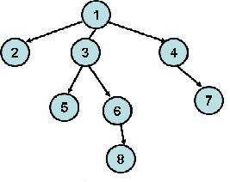
 | 1 | 2 | 3 | 4 | 5 | 6 | 7 | 8
1 | 0 | 1 | 1 | 1 | 0 | 0 | 0 | 0
2 | 1 | 0 | 0 | 0 | 0 | 0 | 0 | 0
3 | 1 | 0 | 0 | 0 | 1 | 1 | 0 | 0
4 | 1 | 0 | 0 | 0 | 0 | 0 | 1 | 0
5 | 0 | 0 | 1 | 0 | 0 | 0 | 0 | 0
6 | 0 | 0 | 1 | 0 | 0 | 0 | 0 | 1
7 | 0 | 0 | 0 | 1 | 0 | 0 | 0 | 0
8 | 0 | 0 | 0 | 0 | 0 | 1 | 0 | 0

Задание 2
1
4
2
31

Задание 3

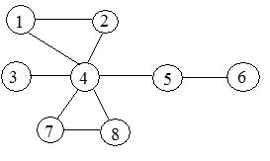

deg 1 = 2, deg 2 = 2, deg 3 = 1, deg 4 = 6,
deg 5 = 2, deg 6 = 1, deg 7 = 2, deg 8 = 2.

deg 1 + deg 2 + deg 3 + deg 4 + deg 5 + deg 6 + deg 7 + deg 8 =18

Проверено.

